1. Define a function called greet that logs “Hello!” to the console. Call the function after defining it.

function greet() {

    console.log("Hello!")

}

greet()

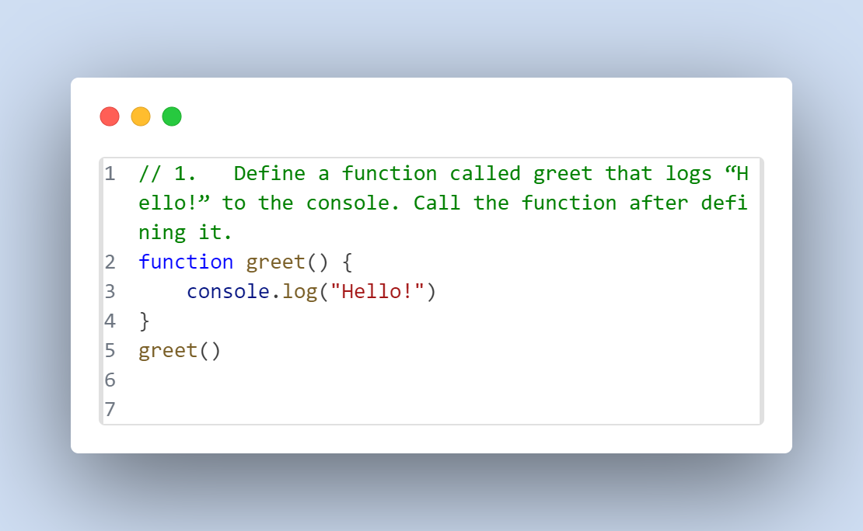

**Hello!**

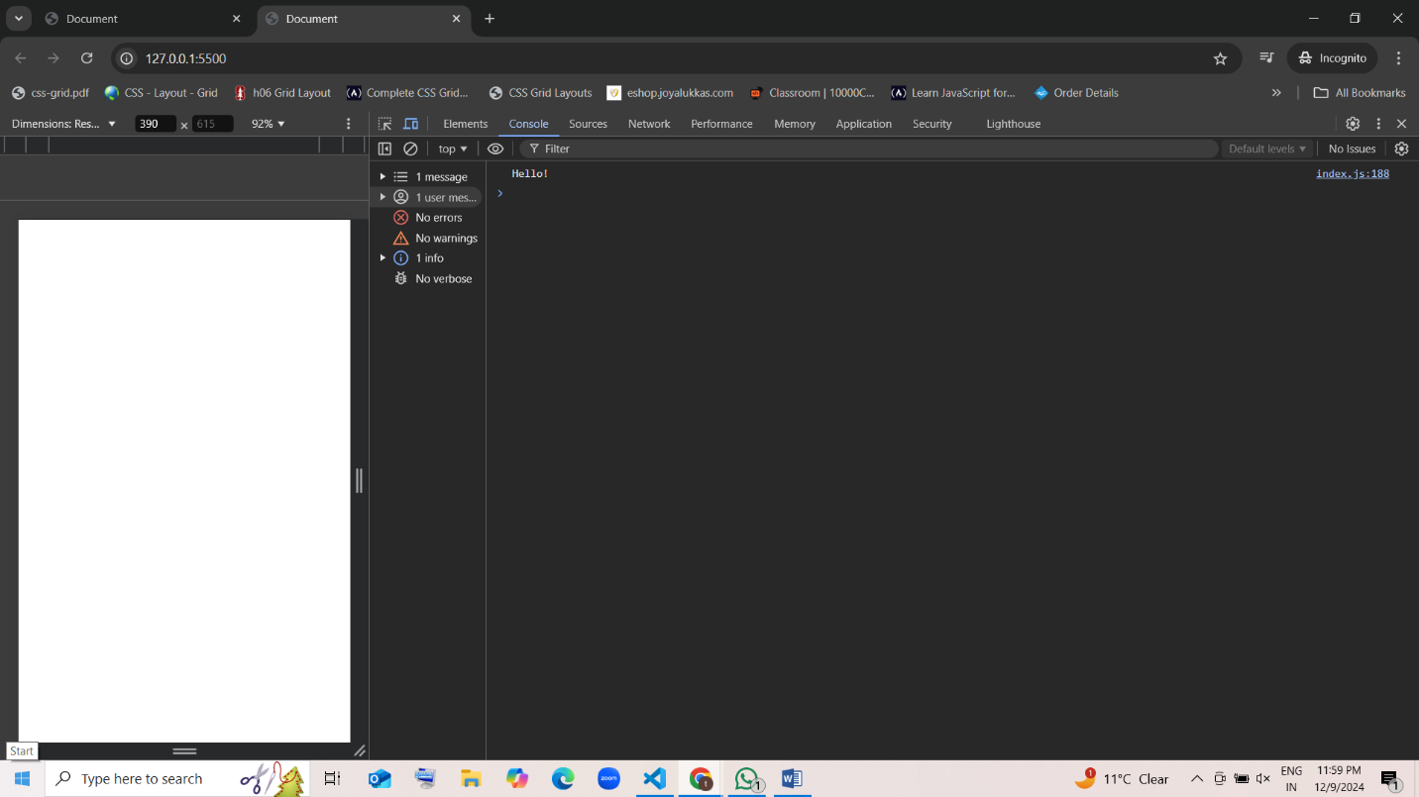

1. Write a function named showMessage that logs “This is a message!” to the console. Call the function once after defining it.

function showMessage() {

    console.log("This is a message!")

}

showMessage()

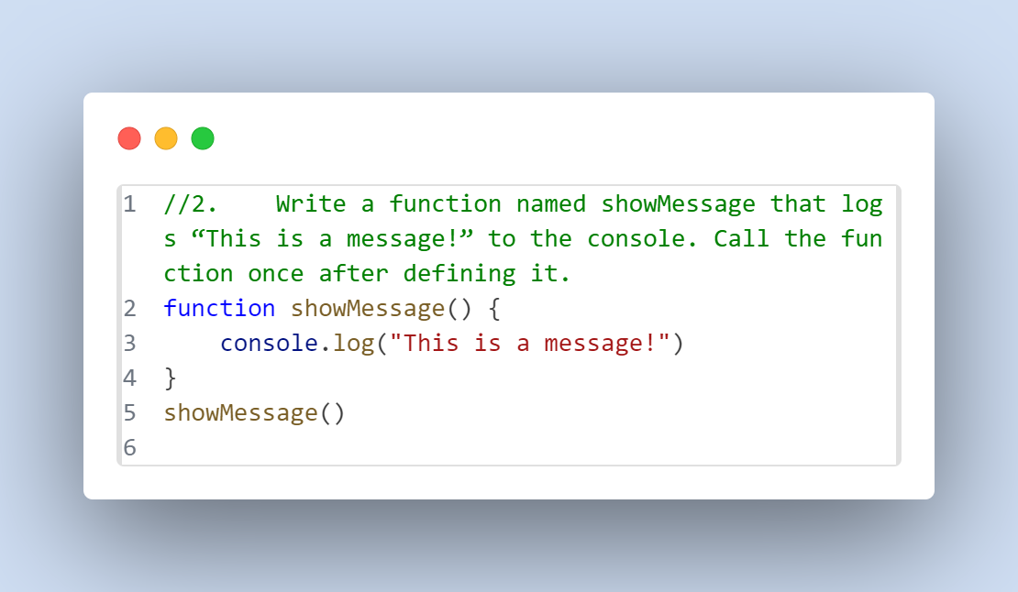

**This is a message!**

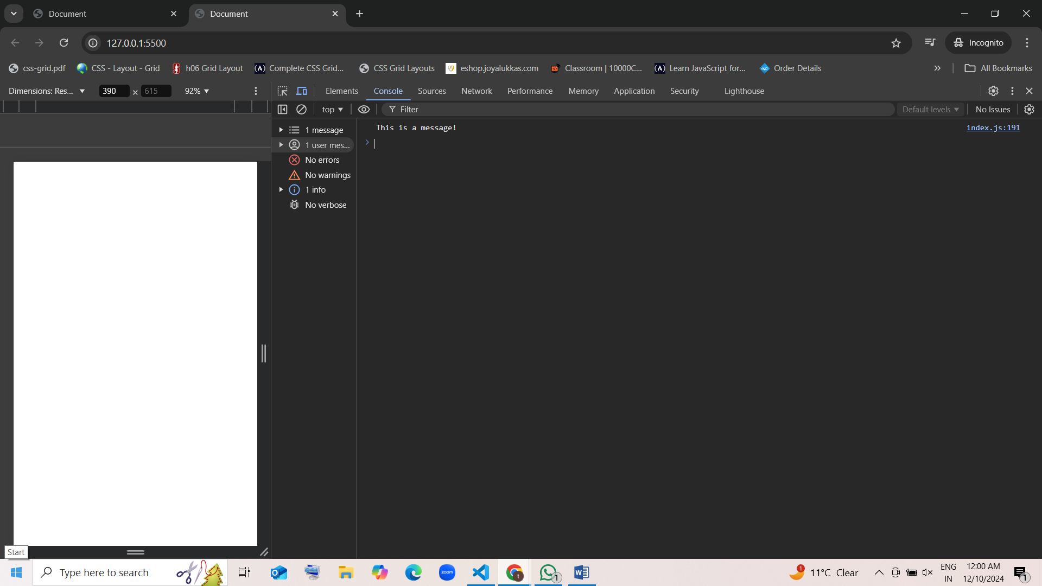

1. Create a function called logInfo that prints “Logging Information…” to the console. Call the function after defining it.

function logInfo() {

    console.log("Logging Information....")

}

logInfo()

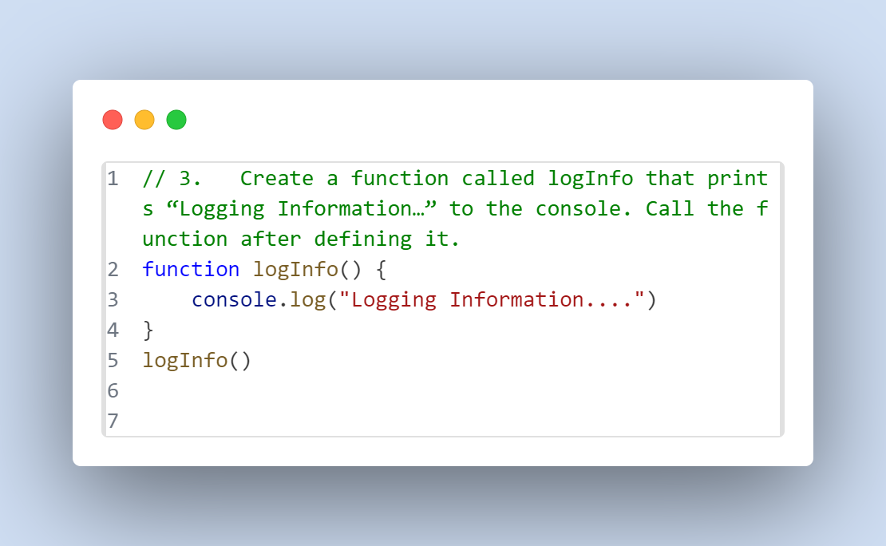

**Logging Information....**

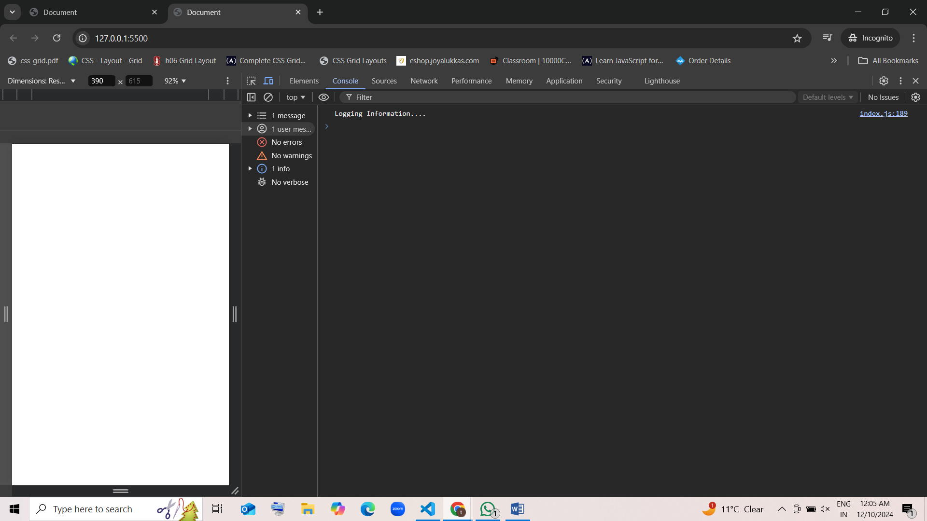

1. Define two functions:
   * startGame that logs “Game Started!”
   * endGame that logs “Game Over!”  
     Inside the startGame function, call the endGame function.

function startGame() {

    console.log("Game Started")

    endGame()

}

function endGame() {

    console.log("Game Over!")

}

startGame()

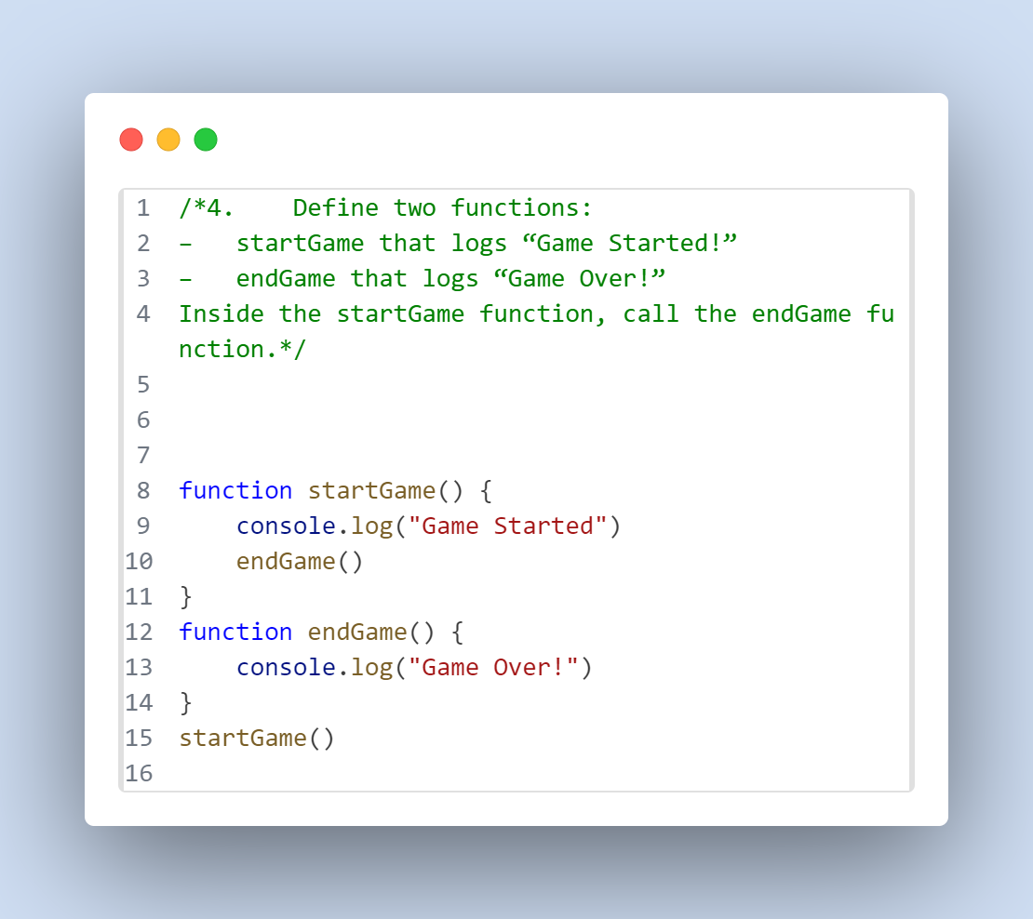

**Game Started**

**Game Over!**

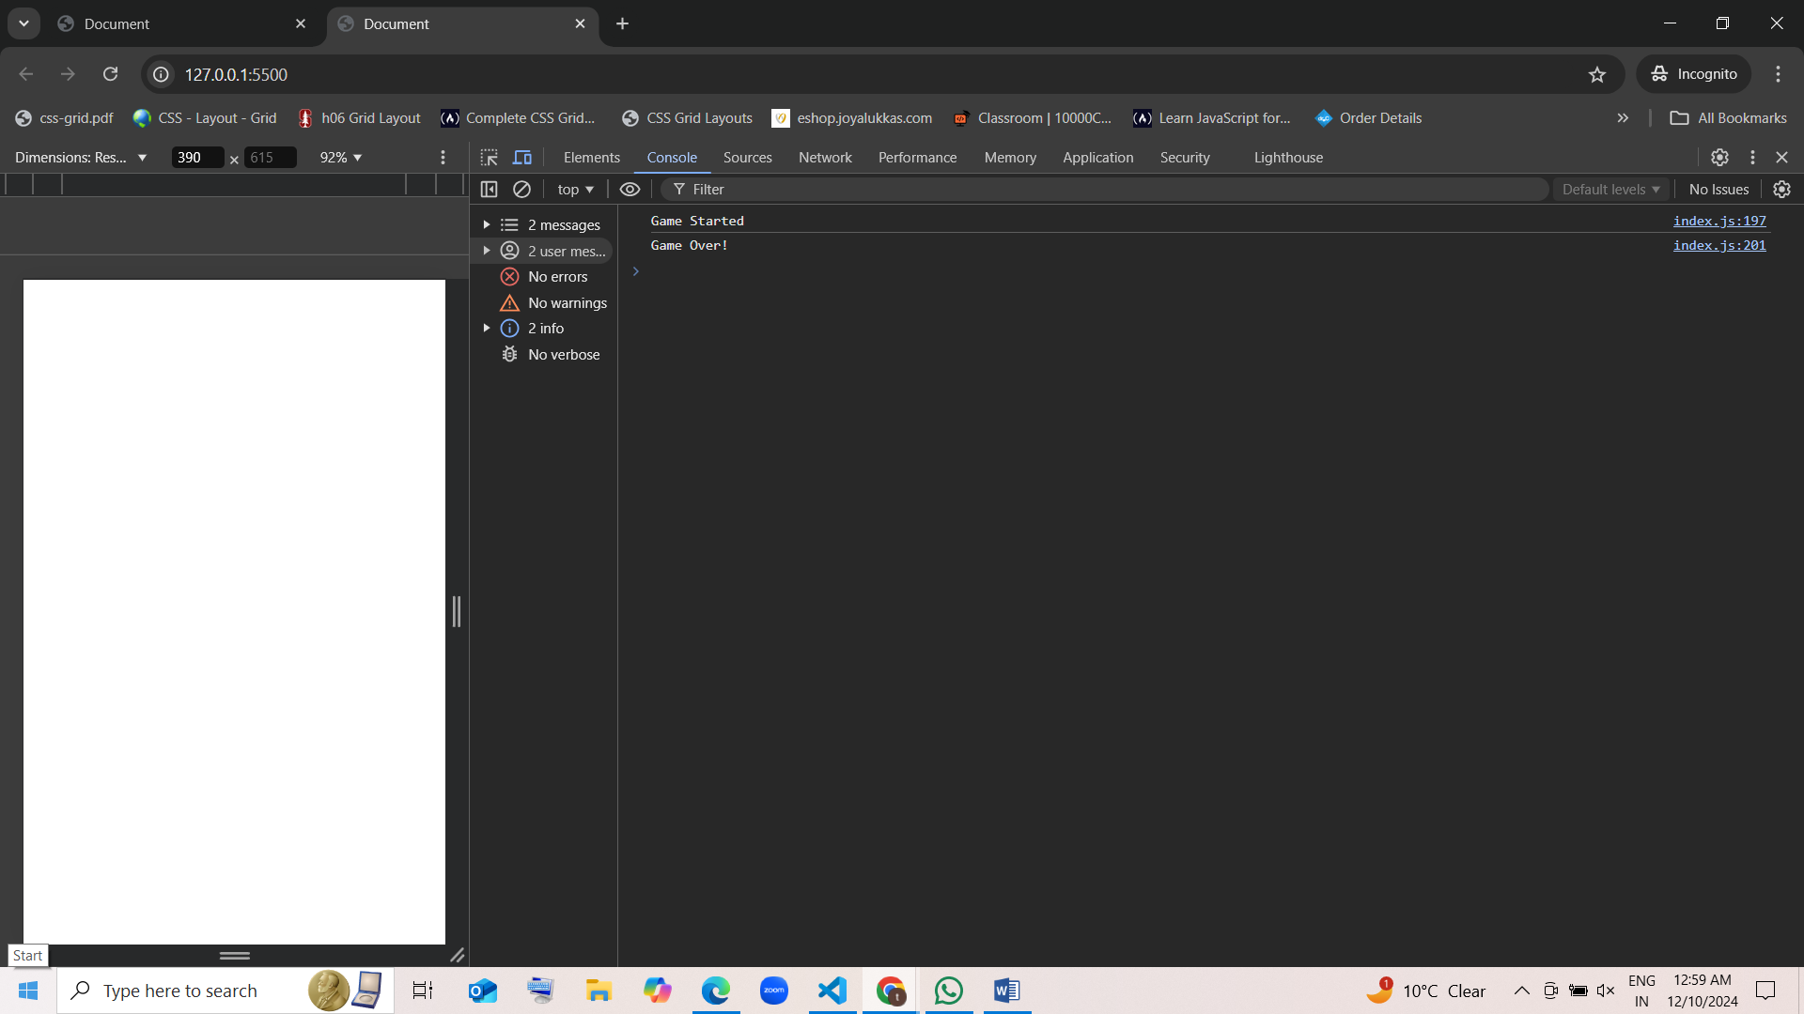

1. Create two functions:
   * beginTask that logs “Task Started”.
   * finishTask that logs “Task Finished”.  
     Inside the beginTask function, call the finishTask function.

function beginTask() {

    console.log("Task Started")

    finishTask()

}

function finishTask() {

    console.log("Task Finished")

}

beginTask()

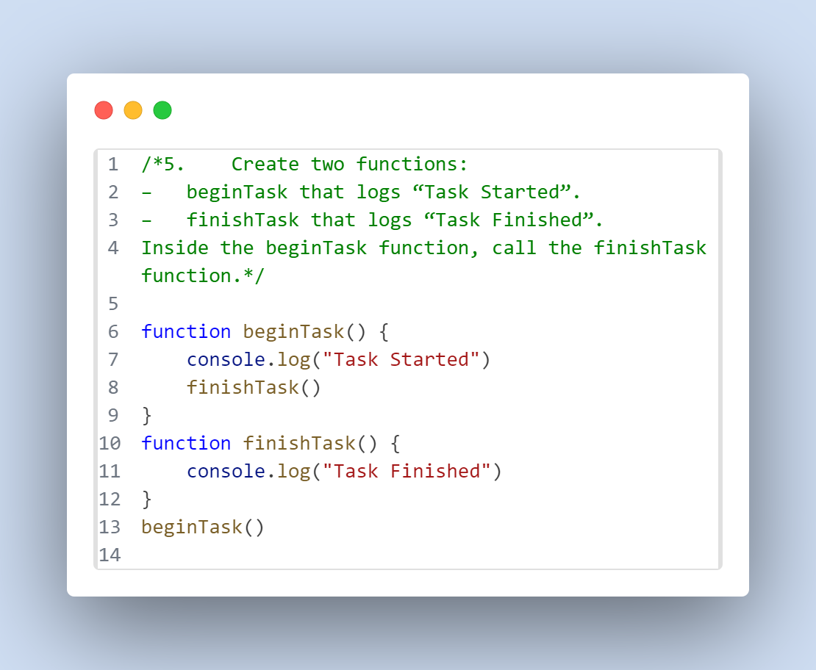

Task Started

Task Finished

* + 